F22-19 Nodose

Collected after 4% PFA perfusion

Overnight in 4% PFA

Sunk in 30% sucrose in PBS

Frozen – stored at -80C

Given to Gloria Limetti for processing in DLAR histopathology lab (9th floor SBST)

Tissue thawed and paraffin-embedded

4 sections sliced by Gloria, on 4 slides. 2 H/E stained – 1 given to Dr. Rigatti, 1 to Horn lab for imaging. 2 unstained slides to Horn lab.

Unstained slides used for Gomori trichrome

1. Deparaffinized and rehydrated using the following protocol: 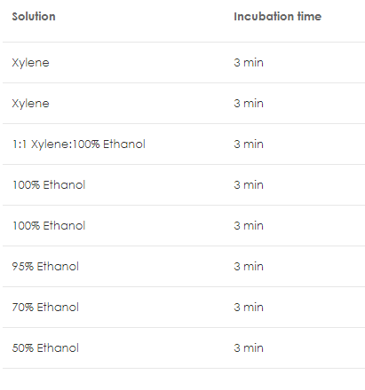[source](https://www.abcam.com/protocols/ihc-deparaffinization-protocol)
2. 3 min in ddH2O
3. 56C Bouin’s solution for 1 hr